ITA0435- STATISTICS WITH R PROGRAMMING FOR VISUALIZATION
NAME : R.SABARISH
REG NO : 192324092
ANALYTICAL ASSIGNMENT 1

1.STUDENT ACADEMIC PERFORMANCE SYSTEM
#CREATE STUDENT DATA
names <- c("Arun", "Bala", "Charan", "Divya", "Esha")

# Marks
math <- c(85, 70, 90, 60, 75)
physics <- c(80, 65, 88, 55, 72)
chemistry <- c(78, 60, 92, 58, 70)

#CALCULATE PASS/FAIL
pass_status <- (math >= 50 & physics >= 50 & chemistry >= 50)

pass_status

#CONVERTING THE ABOVE INTO DATAFRAME
students <- data.frame(
Name = names,
Mathematics = math,
Physics = physics,
Chemistry = chemistry,
Pass = pass_status
)

students

str(students)

#MARKS MATRIX
marks_matrix <- matrix(
c(math, physics, chemistry),
nrow = 5,
ncol = 3
)

colnames(marks_matrix) <- c("Math", "Physics", "Chemistry")

marks_matrix

#STUDENT TOTAL MARK (ROW)
rowSums

#SUBJECT AVERAGE (COLUMN)
colMeans(marks_matrix)

#CONVERTING INTO FACTOR
students$Pass <- factor(students$Pass,
levels = c(TRUE, FALSE),
labels = c("Pass", "Fail"))

students

#ADD TOTAL AND AVERAGE
students$Total <- rowSums(marks_matrix)
students$Average <- students$Total / 3

students

ls()#VIEW OBJ

rm(math) #REMOVE ONE OBJECT

rm(list = ls())#REMOVE ALL OBJECT

OUTPUT :
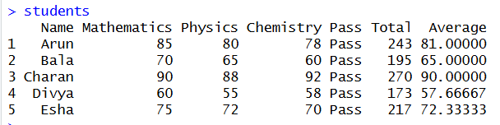
2. HOSPITAL PATIENT MONITORING SYSTEM
#CREATE VARIABLE WITH DATA TYPES
patient_id <- c(101, 102, 103, 104, 105) # Numeric ID
age <- c(45, 60, 50, 38, 70) # Numeric age
gender <- c("Male", "Female", "Male", "Female", "Male") # Character gender
blood_pressure <- c(130, 150, 142, 135, 160) # Numeric BP
diabetic <- c("Yes", "No", "Yes", "No", "Yes") # Character diabetic status

#create a dataframe & convert categorical variables
# Combine into data frame
patients <- data.frame(patient_id, age, gender, blood_pressure, diabetic)

# Convert gender to factor
patients$gender <- factor(patients$gender)

# Convert diabetic status to factor
patients$diabetic <- factor(patients$diabetic)

patients

#identify high risk patients
# Logical condition for high-risk patients
high_risk <- patients$blood_pressure > 140 & patients$diabetic == "Yes"

# Display high-risk patients
patients[high_risk, ]

#create a list to store
# Create list containing mixed data types
hospital_list <- list(patient_id, age, gender, blood_pressure, diabetic)

hospital_list

#create array for multiple day BP reading
# Create 3-day BP readings for 5 patients
bp_array <- array(
c(130,132,128, 150,148,152, 142,140,145, 135,138,136, 160,158,162),
dim = c(5,3),
dimnames = list(
c("P1","P2","P3","P4","P5"),
c("Day1","Day2","Day3")
)
)

bp_array

# Calculate mean BP row-wise
rowMeans(bp_array)

# Find maximum BP value
max(bp_array)

# Calculate average blood pressure
mean(patients$blood_pressure)

# Calculate minimum blood pressure
min(patients$blood_pressure)

# Calculate standard deviation
sd(patients$blood_pressure)

# Calculate total of all BP readings
sum(patients$blood_pressure)

OUTPUT :
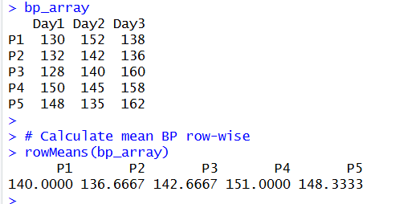

3. E-COMMERCE SALES ANALYSIS

# Create sales matrix (7 days × 4 products)
sales_matrix <- matrix(
c(10,15,12,18,20,14,16, # Product A
8,9,11,10,12,7,13, # Product B
5,6,7,8,9,4,6, # Product C
20,18,22,25,24,19,21), # Product D
nrow = 7,
ncol = 4
)

# Assign column names (products)
colnames(sales_matrix) <- c("ProductA","ProductB","ProductC","ProductD")

# Assign row names (days)
rownames(sales_matrix) <- paste("Day",1:7,sep="")

# Display sales matrix
sales_matrix

# Calculate total sales per day (row-wise)
daily_total <- rowSums(sales_matrix)
daily_total

# Calculate product-wise total sales (column-wise)
product_total <- colSums(sales_matrix)
product_total

# Create price vector for products
price_vector <- c(100, 150, 200, 80)

# Multiply sales by price to calculate revenue matrix
revenue_matrix <- sweep(sales_matrix, 2, price_vector, "*")
revenue_matrix

# Calculate total revenue per product
product_revenue <- colSums(revenue_matrix)
product_revenue

# Calculate total weekly revenue
total_revenue <- sum(revenue_matrix)
total_revenue

# Store product names as character vector
product_names <- c("ProductA","ProductB","ProductC","ProductD")
product_names

# Character vector stores text data and elements must be same type

# Calculate weekly average sales (based on daily totals)
weekly_average <- mean(daily_total)
weekly_average

# Identify days where sales exceeded weekly average
high_sales_days <- daily_total > weekly_average
high_sales_days

# Display high sales days
sales_matrix[high_sales_days, ]

# Example array (3D: day × product × week)
sales_array <- array(sales_matrix, dim = c(7,4,1))
sales_array

# Define S3 class "Product"
Product <- function(name, category, price) {
structure(
list(Name = name, Category = category, Price = price),
class = "Product"
)
}

# Create example product object
p1 <- Product("ProductA", "Electronics", 100)
p1

# Check class of object
class(p1)

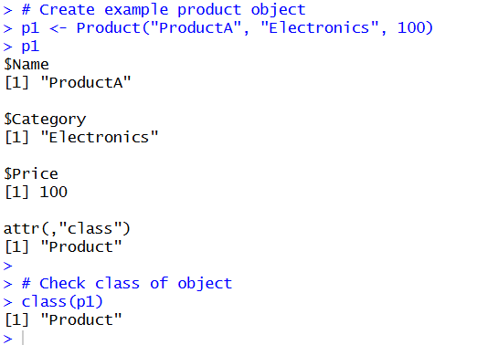
OUTPUT :

4. WEATHER MONITORING SYSTEM
# WEATHER MONITORING SYSTEM

# Create month vector
month <- c("Jan","Feb","Mar","Apr","May","Jun","Jul","Aug","Sep","Oct","Nov","Dec")

# Create temperature vector
temperature <- c(25,27,30,32,35,33,31,30,29,28,26,24)

# Create humidity vector
humidity <- c(60,58,55,50,48,65,70,72,68,63,59,61)

# Create rainfall vector
rainfall <- c(10,15,20,25,40,120,150,130,90,60,30,15)

# Create wind speed vector
wind_speed <- c(8,10,12,15,18,20,22,21,17,14,11,9)

# Combine into data frame
weather_data <- data.frame(month, temperature, humidity, rainfall, wind_speed)

weather_data

# Convert month into factor
weather_data$month <- factor(weather_data$month, levels = month)

weather_data

# Factor is suitable for categorical data with fixed levels

# Create 3D array (month × parameter × year)
weather_array <- array(
c(temperature, humidity, rainfall, wind_speed),
dim = c(12,4,1),
dimnames = list(
month,
c("Temperature","Humidity","Rainfall","WindSpeed"),
"Year1"
)
)

weather_array

# Calculate mean temperature
mean_temperature <- mean(weather_data$temperature)
mean_temperature

# Calculate maximum rainfall
max_rainfall <- max(weather_data$rainfall)
max_rainfall

# Function to calculate seasonal average temperature
seasonal_avg <- function(temp_vector) {
winter <- mean(temp_vector[c(12,1,2)])
summer <- mean(temp_vector[c(3,4,5)])
monsoon <- mean(temp_vector[c(6,7,8,9)])
post_monsoon <- mean(temp_vector[c(10,11)])
return(list(Winter=winter, Summer=summer, Monsoon=monsoon, PostMonsoon=post_monsoon))
}

# Call function
seasonal_avg(temperature)

# Arrays can store data in more than two dimensions while matrices are strictly two-dimensional

OUTPUT :
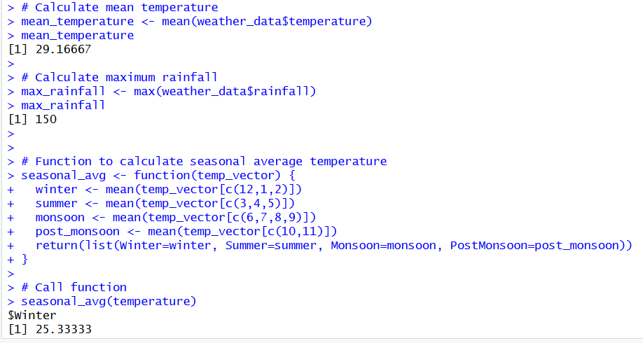

5. BANKING LOAN RISK CLASSIFICATION SYSTEM

# BANK LOAN APPLICANT ANALYSIS

# Create vectors for each variable
age <- c(25, 40, 35, 28, 50)
income <- c(45000, 60000, 75000, 52000, 90000)
credit_score <- c(680, 720, 710, 690, 750)
employment_status <- c("Employed", "Self-Employed", "Employed", "Unemployed", "Employed")
loan_approval <- c("No", "Yes", "Yes", "No", "Yes")

# Create data frame
loan_data <- data.frame(age, income, credit_score, employment_status, loan_approval)

loan_data

# Convert categorical variables into factors
loan_data$employment_status <- factor(loan_data$employment_status)
loan_data$loan_approval <- factor(loan_data$loan_approval)

loan_data

# Logical condition: income > 50000 and credit_score > 700
eligible_applicants <- loan_data$income > 50000 & loan_data$credit_score > 700

eligible_applicants

# Display eligible applicants
loan_data[eligible_applicants, ]

# Create matrix of financial indicators (income and credit score)
financial_matrix <- as.matrix(loan_data[, c("income", "credit_score")])

financial_matrix

# Calculate column means
colMeans(financial_matrix)

# Matrix transpose
t(financial_matrix)

# Matrix multiplication example
financial_matrix %*% matrix(c(1,1), ncol=1)

# Define S4 class "LoanApplicant"
setClass(
"LoanApplicant",
slots = list(
age = "numeric",
income = "numeric",
credit_score = "numeric",
employment_status = "character",
loan_approval = "character"
)
)

# Create object of S4 class
applicant1 <- new("LoanApplicant",
age = 30,
income = 65000,
credit_score = 720,
employment_status = "Employed",
loan_approval = "Yes")

applicant1

# S3 is informal and flexible class system
# S4 is formal class system with defined slots and data validation
# Reference class supports object-oriented programming with mutable objects

OUTPUT :
